**Grades**

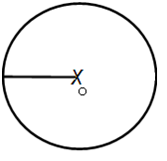 0 is the center of circle

Diameter = 2 x radious

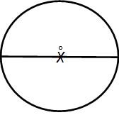 Diameter

**Semi-Circle**

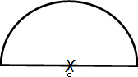

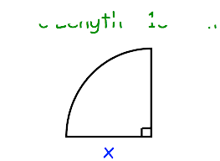**Quarter Circle (Quadrant)**

**Geometry**

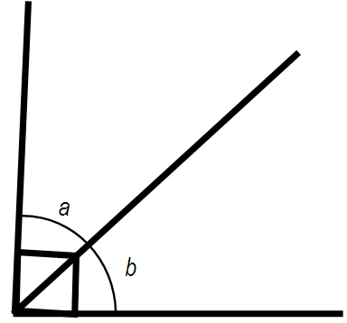

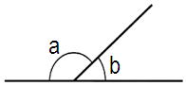

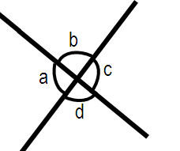

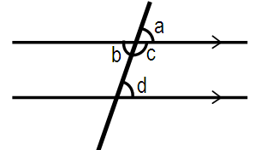

**Triangle**

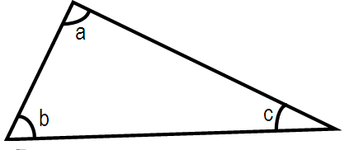

**Isosceles Triangle**

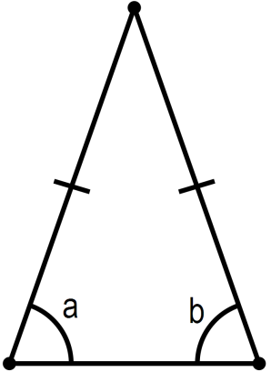

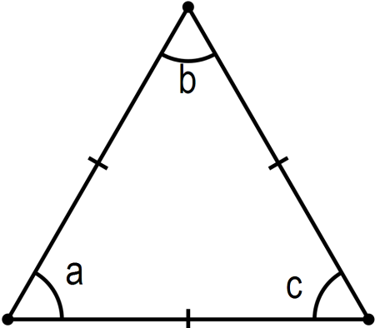**Equilateral Triangle**

**Trapezium**

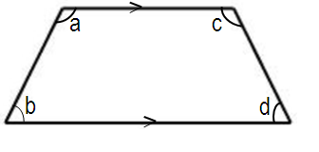

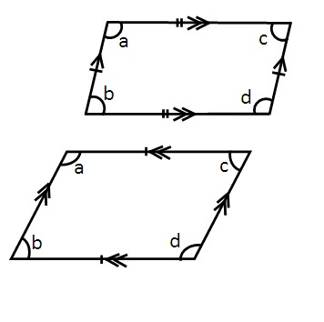**Parallelogram**

**Rhombus**

**Fractions**

**Ratio**

**Decimals**

**Percentage**

**Percentage Increase / Decrease**

**Percentage Discount**

**Percentage Profit/ Loss**

Cost Price + Profit = Selling Price

**Speed**

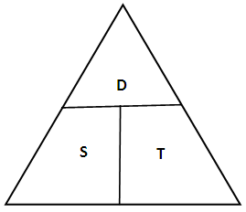

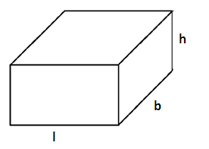

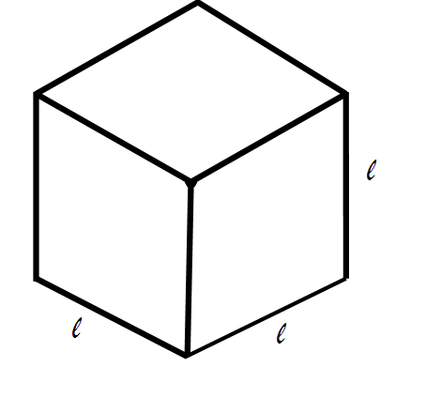**Cube**

Average

**Square Numbers Cubic Numbers**

1x 1 =1 1x1x1=1

2x2=4 2x2x2=8

3x3=9 3x3x3=27

4x4=16 4x4x4=64

5x5=25 6x6x6=216

6x6=36 7x7x7=343

7x7=49 8x8x8=512

8x8=64 9x9x9=729

9x9=81 10x10x10=1000

10x10=100 11x11x11=1331

11x11=121 12x12x12=1728

12x12=144

13x13=164

14x14=196

15x15=125

**Primary Math’s Formula List**

**Conversation Table**

Length

10mm= 1cm

1m= 100cm

1km= 1000m

**Mass**

1Kg = 1000g

**Volume**

**Time**

1 Hour = 60 Minutes

1 Minutes = 60 Seconds

1 Hours = 3600 Minutes

**Area and perimeter**

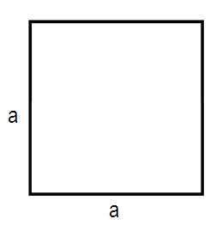**Square**

Area of Square = length x length

= a x a

Perimeter of square = 4 x length

**Rectangle**

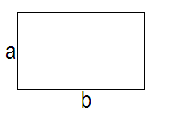  
 Area of Rectangle = Length x Breadth

Perimeter of Rectangle = 2length +Breadth

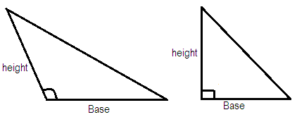**Triangles**

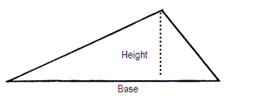

Area of Triangles =

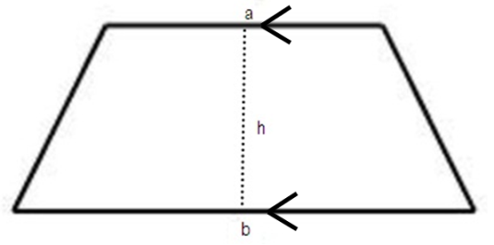**Trapezium**

Area of Trapezium

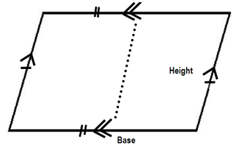**Parallelogram**

Area of Parallelogram and Rhombus = Base x Height

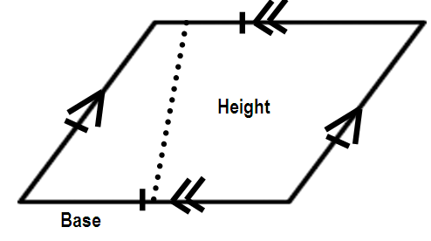**Rhombus**

**E Maths Formula List**

**Integers**

**Prime Numbers** – Numbers with only 2 factors, land itself. Eg : 2,3,5,7………

**Composite Number** – Numbers with at last 3 distinct factors. Eg 4,6,8,9……..

**Rational Number**– Numbers that can be expressed infraction Eg 1,

Irrational Number – Numbers that cannot be expressed in fraction Eg.

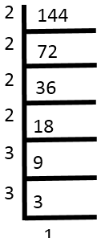**Indices Express in index notation**

**Standards Form**

**Express in index form**

**Expression Standard form**

**Greek Prefix Multiplying Factor**

Tera

Giga

Mega

Kilo

Mili

Mioro

Nano

Pico

Million

Billion

Trillion

**Conversion**

1km =

1cm =

1cm =

1 hectare = 100 acres =

**Direct and Inverse Proportion**

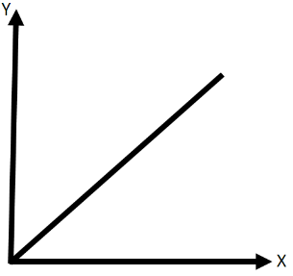Y is directly proportional to

Y is inversely proportional

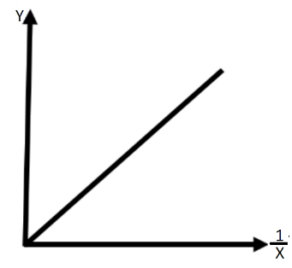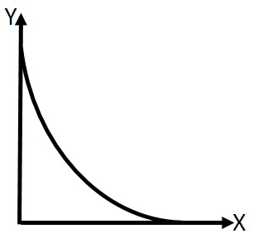

% increase or decrease

**Algebra Expansim and Factorization**

**Quadratic Equations**

**Completing the Square**

**Statistics**

**Coordinate Geometry**

**Graph**

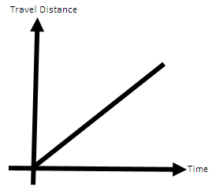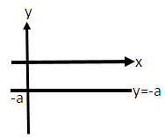Important Shapes of Graph

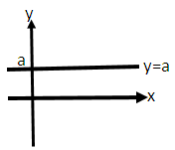

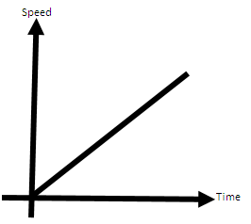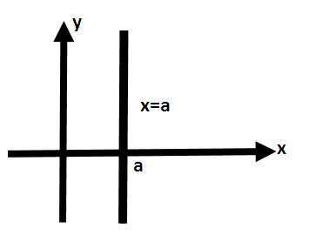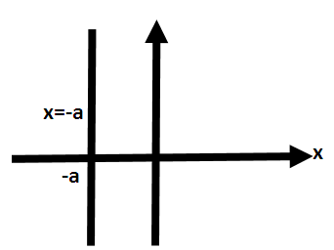 Speed = Gradient of Distant- Time Graph = Speed

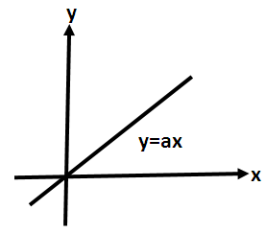

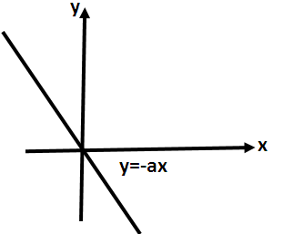

Distance = Speed x Time

Area of Speed – Time Graph = Distance

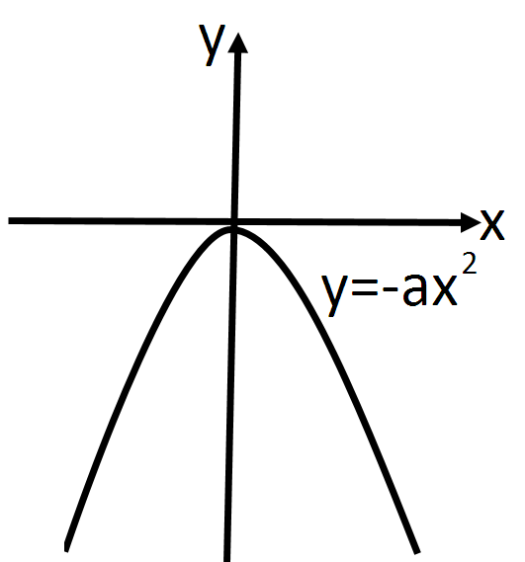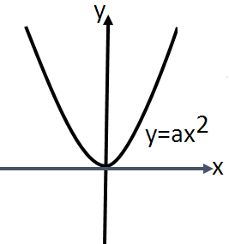 Accelerate / Deceleration =

Gradient of Speed – Time Graph

= Acceleration / Deceleration

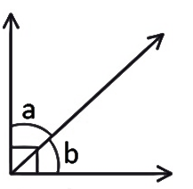 **Geometry**

Complimentary

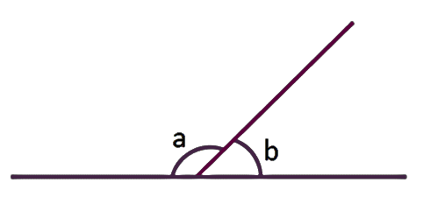

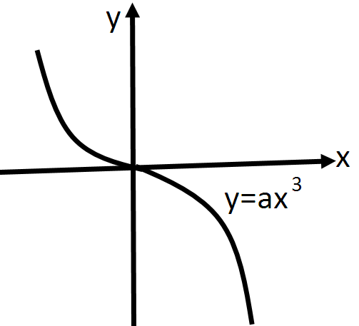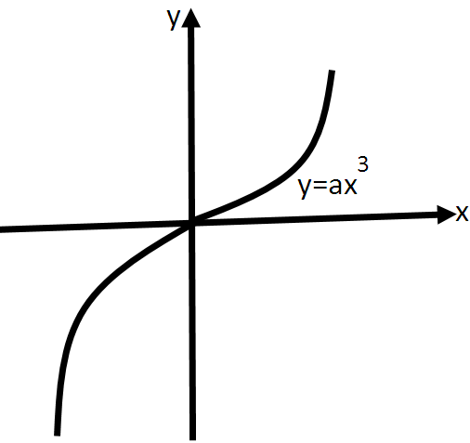

Supplementary

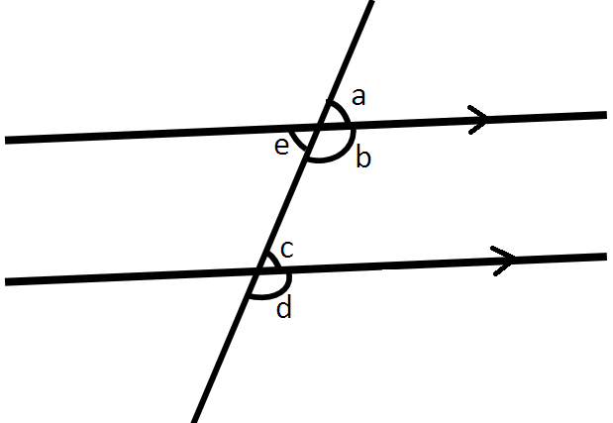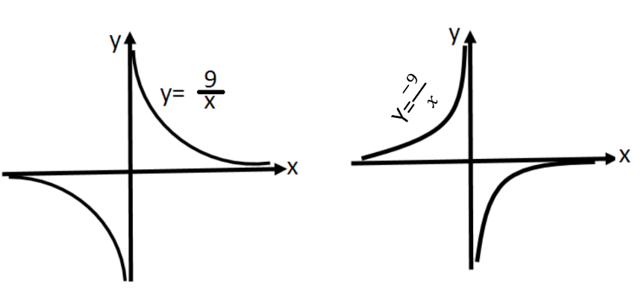

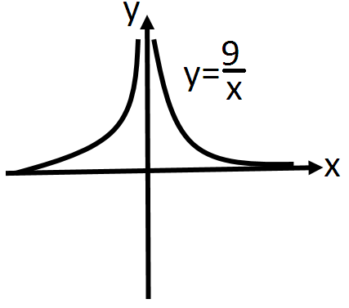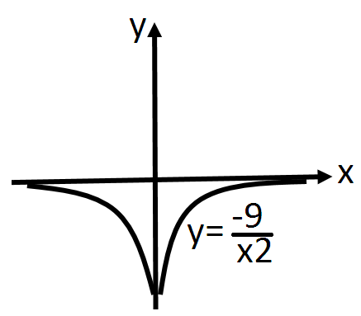

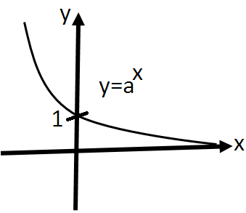

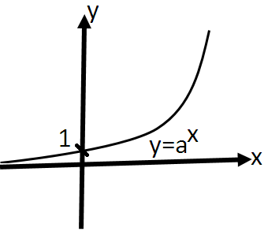

**Triangle**

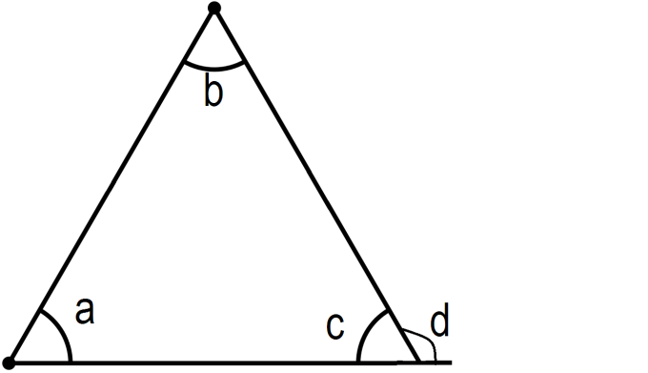

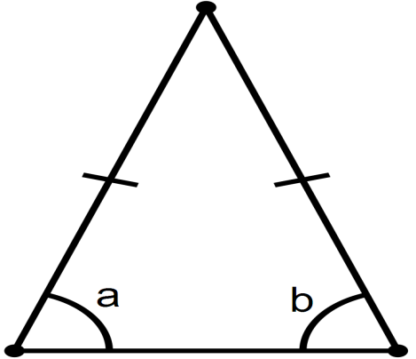

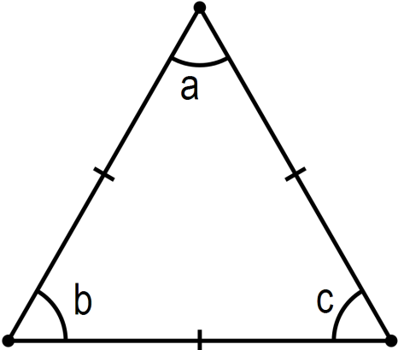

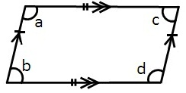**Parallelogram**

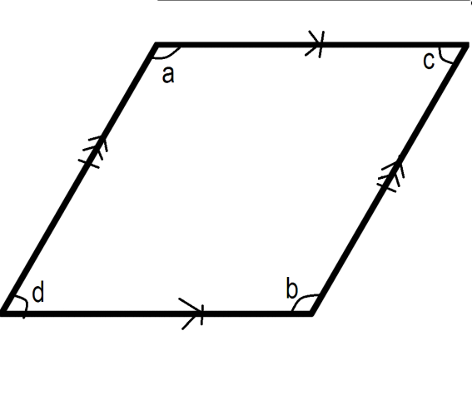**Rhombus**

**Trapezium**



**Circes**

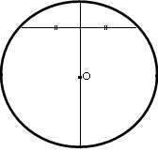 **When radius is**

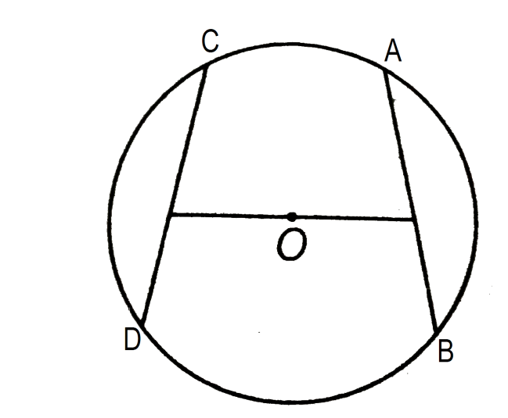

AB =CD

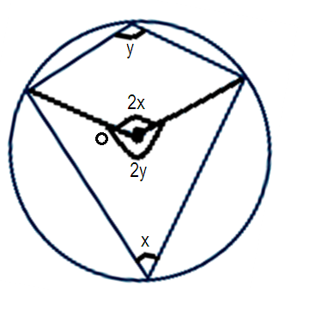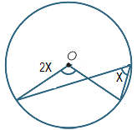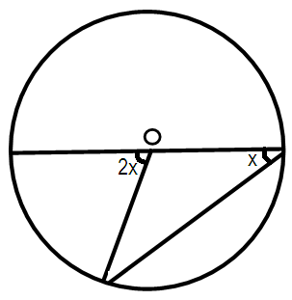

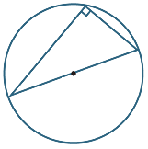

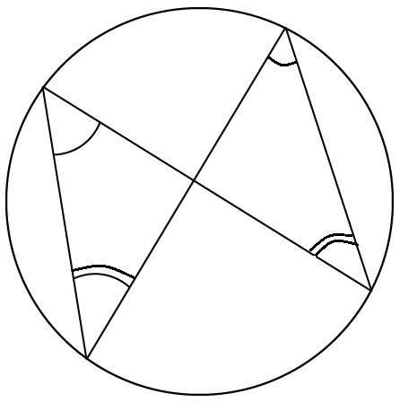

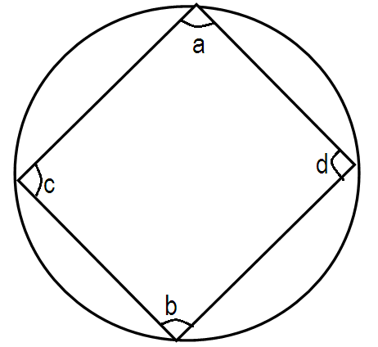

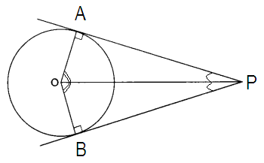

**Polygons**

3 sides – triangle

4 sides – quadrilateral

5 sides – pentagon

6 sides – hexagon

7 sides – heptagon

8 sides – octagon

9 sides – nonagon

10 sides – decagon

Sum of interior

Each interior

Each interior

Similarity and congruency

**Congruency**

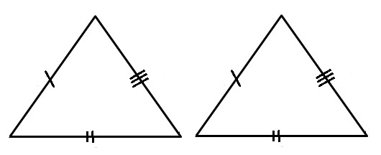2 figures have same shape and same size

SSS congruency

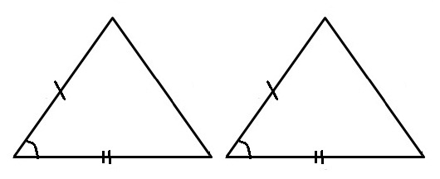

SAS Congruency

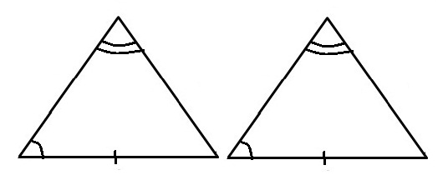

AAS Congruency

**Similarity**

2 figures have same shape but different size

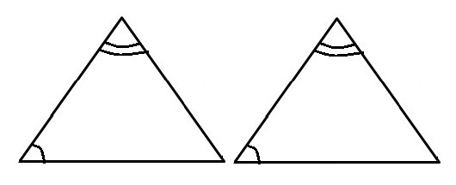



AA Similarity

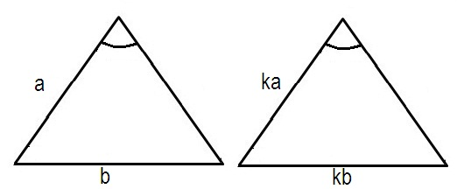

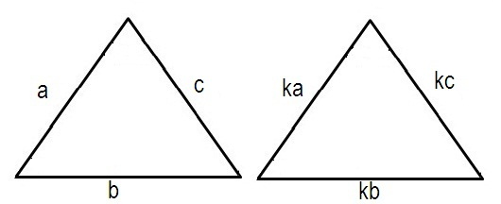

If 2 figure are similar

Trigonometry

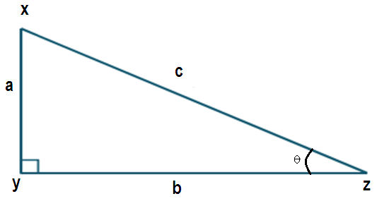

By converse of Pythagoras theorem, ABC is a right angle triangle angled triangle

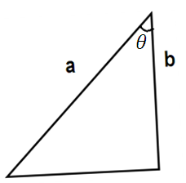

*𝐴𝑟𝑒𝑎=*

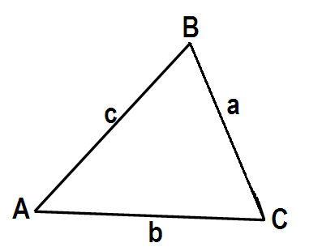

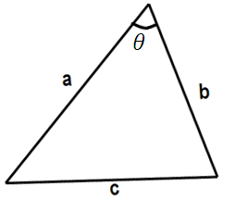

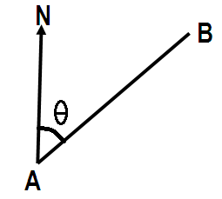**Bearings**

Bearing of B from A

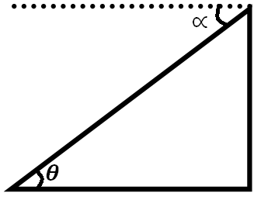

Angle of elevation

Angle of depression

Angle of elevation =angle of depression

**Area & Perimeter**

Triangle

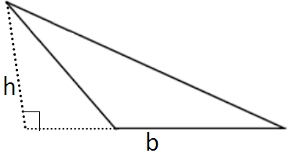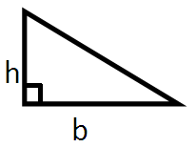Perimeter=Sum of lengths of all 3 sides

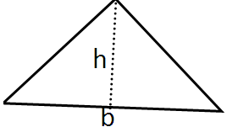Area = x Base x Height

**Trapezium**

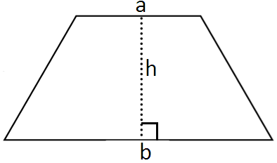Perimeter = Sum of lengths of all 4 sides

Area = x (a+b) x h

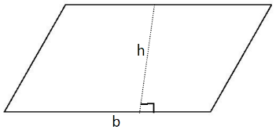**Parallelogram**

Perimeter = Sum of lengths of all 4 sides

Area = Base x Perpendicular Height

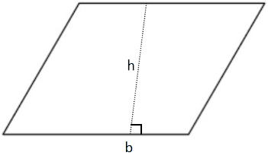**Rhombus**

Perimeter = 4 x length

Area = Length x Perpendicular Height

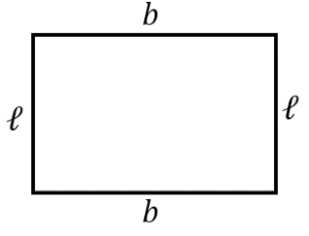

**Rectangle**

Perimeter = =2

Area=

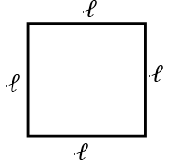**Square**

Perimeter =

Area =

Kite

Perimeter = Sum of length of all 4 sides

Area = (where a and b are lengths of 2 diagonals)

**Circle**

Circumference = or

Area =

Semi-Circle

Perimeter =

Area =

**Quadrant**

Perimeter =

Area =

**Sector**

Area of sector = (in degree) (in radian)

Arc Length = (in degree) (in radian)

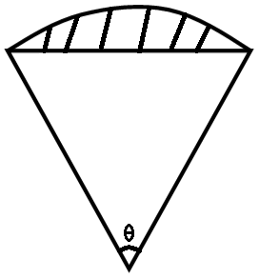Area of Segment = Area of sector – Area of triangle

**Solid Figures**

**Cube**

Surface Area =

Volume =



**Cuboid**

Surface Area =

Volume =

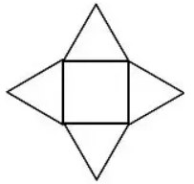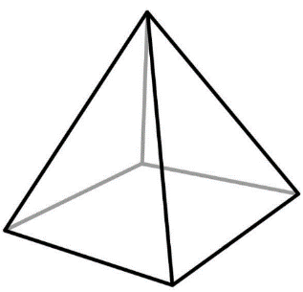**Pyramid**

Surface Area = Base Area + 4 Triangles

Volume = Base Area x Perpendicular Height

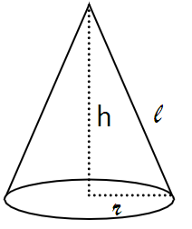**Cone**

Curve Surface Area

Volume =

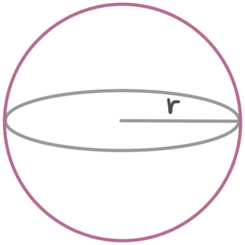

**Sphere**

Surface area =

Volume =

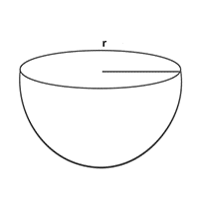**Hemisphere**

Curve Surface area =

Total Surface Area

Volume =

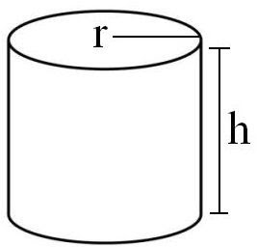**Cylinder**

Curve Surface area =

Open Cylinder Surface Area= 2

Close Cylinder Surface Area =

Volume =

**Vectors**

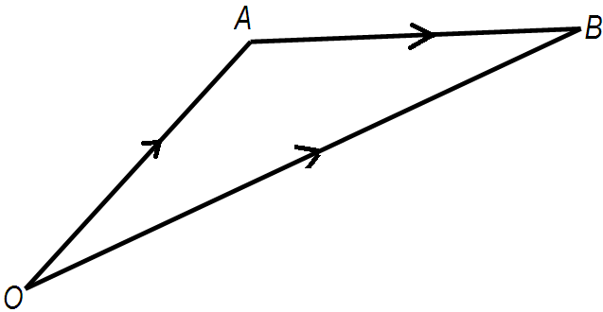

If A has coordinate (x,y)